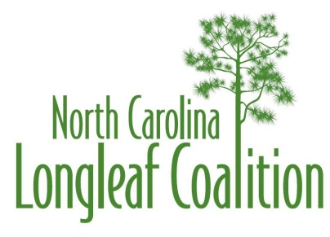

ANNUAL AWARD NOMINATION
for
Illustris Palustris Award
The Illustris Palustris Award is presented to an individual who deserves recognition for his/her significant contribution to the longleaf efforts in North Carolina. The award includes a certificate or plaque and a copy of the commendation read at the awards ceremony.
(Please type or neatly print all entries)

1. Name of nominee:
2. Address of nominee:
______ __________________________

3. Employer of nominee:
4. Telephone number of nominee __________ ___
(Business) (Residence)
5. E-mail address of nominee: _

6. Describe the nominee’s outstanding service and contributions towards the longleaf pine effort in North Carolina. His or her contributions must exemplify the mission of the North Carolina Longleaf Coalition. What has the nominee accomplished that causes you to believe he or she is the best-qualified candidate for this award? What has the nominee accomplished beyond those expectations of their regular job? Be explicit, concise, and factual. Continue on additional sheets if necessary.

7. Submitted by:
Address:

Telephone/E-mail:

Mail nomination so as to arrive no later than July 10, 2019 to:
Bill Pickens
NC Forest Service
2411 Old US 70 West
Clayton, NC 27520

OR
bill.pickens@ncagr.gov

